

COMPUTER SCIENCE DEPARTMENT

Total Marks: | 7.5
Obtained Marks:

Computer Networks and Data Communications

Design and Implementation of a Small Business Network using Cisco Packet Tracer

Submitted To: Sir Ammad Noor

Student Name: Ubaid Bin Waris, Mushahid Hussain, Muhammad Salman, Saifullah Shakut

Reg Number: 2212416, 2212408, 2212400, 2212411

COMPUTER SCIENCE DEPARTMENT

Table of Contents
- Introduction
- Goals
- Purpose
- Project Scope
- Network Design Overview
- Network Topology and Configuration
- Diagram
- Security Implementation
- Testing and Verification
- Conclusion

COMPUTER SCIENCE DEPARTMENT

Introduction:
The "Design and Implementation of a Small Business Network using Cisco Packet Tracer" project aims to develop a comprehensive network infrastructure suitable for a small business environment. This report outlines the design and implementation process of the network, emphasizing its importance in facilitating efficient communication and resource sharing within the organization.

Goals:
The goals of this project are to:

  - Design a scalable and reliable network infrastructure tailored to the needs of a small business.
  - Implement network configurations using Cisco Packet Tracer to ensure seamless connectivity and optimal performance.
  - Enhance network security measures to safeguard against potential threats and unauthorized access.
  - Provide documentation and presentations to demonstrate the effectiveness and functionality of the designed network.

Purpose:
The purpose of this project is to address the networking requirements of a small business by designing and implementing a robust network infrastructure using Cisco Packet Tracer. By doing so, we aim to optimize communication channels, improve resource utilization, and facilitate business operations effectively.

Project Scope:
The "Design and Implementation of a Small Business Network using Cisco Packet Tracer" project encompasses the following scope:
- Analysis of Networking Requirements: Assessing the specific needs and requirements of the small business to tailor the network design accordingly.

- Design and Configuration: Developing a network topology and configuring network devices such as routers, switches, PCs, and servers using Cisco Packet Tracer.

- Security Implementation: Implementing security measures including firewalls, access control lists (ACLs), and encryption protocols to ensure network integrity and confidentiality.

- Testing and Verification: Conducting comprehensive testing to verify network functionality, performance, and security features.

- Documentation and Presentation: Creating detailed documentation and presentations to showcase the project objectives, methodology, and outcomes.

COMPUTER SCIENCE DEPARTMENT

Network Design Overview:
The network design comprises multiple interconnected devices including routers, switches, PCs, and servers arranged in a hierarchical topology. The design aims to optimize network performance, scalability, and reliability while ensuring ease of management and administration.

Network Topology and Configuration:
The network topology consists of core, distribution, and access layers interconnected using routers and switches. Each layer is designed to fulfill specific functions such as routing, switching, and access control. The configuration of network devices is done meticulously to establish communication channels and facilitate seamless data transfer within the network.

Diagram:

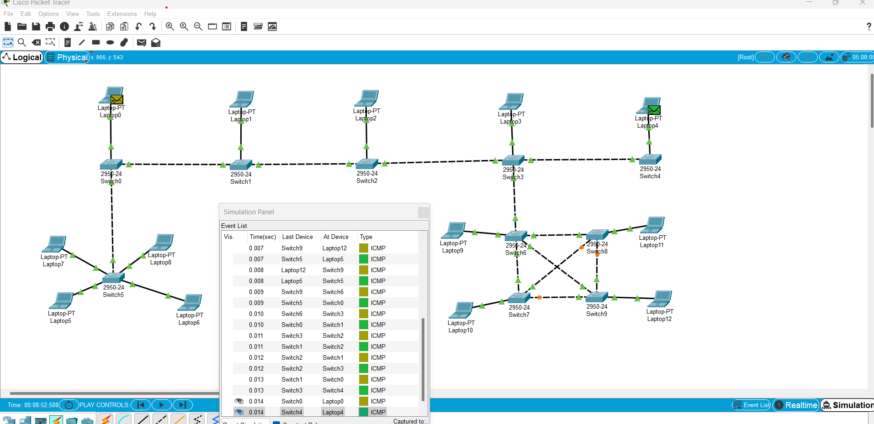

Security Implementation:
Security measures are integrated into the network design to mitigate potential risks and vulnerabilities. Firewalls are deployed to monitor and control incoming and outgoing traffic, while ACLs are used to enforce access policies and restrict unauthorized access to network resources. Additionally, encryption protocols are employed to ensure data confidentiality and integrity.

Testing and Verification:
Thorough testing is conducted to validate the functionality and performance of the designed network. Tests include connectivity checks, traffic analysis, and security assessments to identify any potential issues or bottlenecks. Verification procedures are implemented to ensure that the network meets the specified requirements and objectives.

- Conclusion:
The "Design and Implementation of a Small Business Network using Cisco Packet Tracer" project successfully addresses the networking needs of a small business by providing a scalable, reliable, and secure network infrastructure. Through meticulous design, configuration, and testing, the project demonstrates the effectiveness of Cisco Packet Tracer in simulating real-world networking scenarios and facilitating practical learning experiences.

